SQL05-SETS – MINUS – need fixing to use my data

**Summary**: in this tutorial, you will learn how to use the Oracle MINUS operator to subtract one result set from another.

Introduction to Oracle MINUS Operator

The Oracle MINUS operator compares two queries and returns [distinct](https://www.oracletutorial.com/oracle-basics/oracle-select-distinct/) rows from the first [query](https://www.oracletutorial.com/oracle-basics/oracle-select/) that are not output by the second query. In other words, the MINUS operator subtracts one result set from another.

The following illustrates the syntax of the Oracle MINUS operator:

SELECT column_list_1

FROM T1

MINUS

SELECT column_list_2

FROM T2;

Code language: SQL (Structured Query Language) (sql)

Similar to the [UNION](https://www.oracletutorial.com/oracle-basics/oracle-union/) and [INTERSECT](https://www.oracletutorial.com/oracle-basics/oracle-intersect/) operators, the queries above must conform with the following rules:

* The number of columns and their orders must match.
* The [data type](https://www.oracletutorial.com/oracle-basics/oracle-data-types/) of the corresponding columns must be in the same data type group such as numeric or character.

Suppose the first query returns the T1 result set that includes 1, 2 and 3. And the second query returns the T2 result set that includes 2, 3 and 4.

The following picture illustrates the result of the MINUS of T1 and T2:

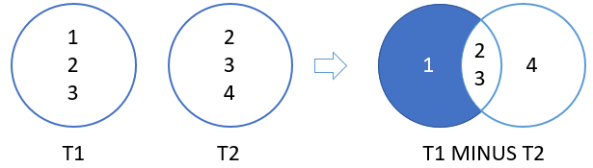

Oracle MINUS examples

See the following contacts and employees tables in the [sample database](https://www.oracletutorial.com/getting-started/oracle-sample-database/):

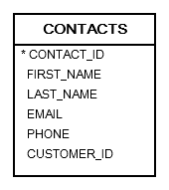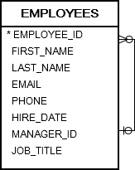

The following statement returns distinct last names from the query to the left of the MINUS operator which are not also found in the right query.

SELECT last_name

FROM contacts

MINUS

SELECT last_name

FROM employees

ORDER BY last_name;

Code language: SQL (Structured Query Language) (sql)

Here are the last names returned by the first query but are not found in the result set of the second query:

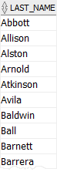

See the following products and inventories tables:

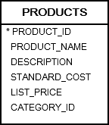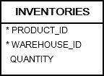

The following statement returns a list of product id from the products table, but do not exist in the inventories table:

SELECT

product_id

FROM

products

MINUS

SELECT

product_id

FROM

inventories;

Code language: SQL (Structured Query Language) (sql)

Here is the result:

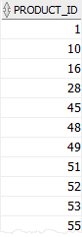

In this tutorial, you have learned how to use the Oracle MINUS operator to compare two queries and return the distinct rows from the first query that are not output by the second query.